A Project Report On

SkillAnce

Submitted in partial fulfillment of the requirement for the award of the degree

MASTER OF COMPUTER APPLICATIONS

(M.C.A.)

Academic Year 2024 – 25

Raj Kumar (92300584116)

Internal Guide
Prof. Jignesh Jentilal Kariya



Rajkot-Morbi Road, At & PO: Gauridad, Rajkot 360 003. Gujarat. India.



Faculty of Computer Applications (FCA)



This is to certify that the project work entitled

SkillAnce

submitted in partial fulfillment of the requirement for

the award of the degree of

MASTER OF COMPUTER APPLICATIONS

(M.C.A.)

of the

Marwadi University

is a result of the bonafide work carried out by

Raj Kumar(92300584116)

during the academic year 2024-25

Faculty Guide |  | HOD |  | Dean

DECLARATION

I / We hereby declare that this project work entitled SkillAnce is a record done by me/us.

I / We also declare that the matter embodied in this project is genuine work done by me / us and has not been submitted whether to this University or to any other University / Institute for the fulfillment of any course of study.

Place:
Date:

Raj Kumar (92300584116) Signature:

ACKNOWLEDGEMENT

It is indeed a great pleasure to express my/our thanks and gratitude to all those who helped me/us. No serious and lasting achievement one can ever achieve without the help of friendly guidance and co-operation of so many people involved in the work.

I/We am/are very thankful to my/our faculty guide Prof. Jignesh Jentilal Kariya Sir, the person who makes me/us follow the right steps during project work. I/we express my/our deep sense of gratitude to his/her guidance, suggestions and expertise at every stage. Apart from that his/her valuable and expertise suggestion during documentation of my/our report indeed helped me/us a lot.

Thanks to my/our friends who have been a source of inspiration and motivation that helped me/us during my/our project work. I/we am/are also thankful to my/our Head Dr. Sunil Bajeja and Dean Dr. R. Sridaran for their support as and when required. I/we would like to extend my/our gratitude towards all who directly or indirectly supported and helped me/us to accomplish my/our project work.

Raj Kumar (92300584116) Signature:

CERITIFICATE



COMPANY PROFILE

As the creator of my freelancing website using the MERN stack, I am gaining

hands-on experience in full-stack web development. My work involves building

and optimizing a dynamic platform, handling everything from database design

to frontend and backend implementation. I collaborate with developers, explore

modern web technologies, and apply best practices to enhance user experience.

This project is helping me strengthen my skills in JavaScript, React, Node.js,

MongoDB, and web development while allowing me to build a practical and

Impactful solution.
CONTENTS

Chapters | Particulars | Page No.
1 | SYNOPSIS | 1-2
2  2.1  2.2  2.3  2.4  2.5  2.6 | PREAMBLE  General Introduction  Statement of Problem  Objective and Scope of the Study  Module Description with functionality  Methodology  Feasibility Study | 3-15
3  3.1 | REVIEW OF LITERATURE  (Study of Existing Similar Types of Systems) | 16-18
4  4.1  4.2 | TECHNICAL DESCRIPTION  Hardware Requirement  Software Requirement | 19-20
5  5.1  5.2  5.3  5.3.1  5.4  5.4.1  5.4.2  5.4.3  5.5  5.5.1  5.5.2  5.6  5.7 | SYSTEM DESIGN AND DEVELOPMENT  (Only applicable diagrams)  Architectural Design / System Flow  Data Flow Diagram (DFD)  Structural Modeling  - Class Diagram  Behavioral Modeling  - Use Case Diagram  - Sequence Diagram  - Activity Diagram  Database Design  - Table Structure  - Entity Relationship Diagram  Menu Design  Screen Design (Screen shots with short description) | 21-39
6  6.1  6.2  6.3  6.4 | SYSTEM TESTING  Testing and Implementation  Testing Methodology  Test Case Design  System Implementation Strategy | 40-43
7 | CONCLUSION | 44
8 | LEARNING DURING PROJECT WORK | 45-46
9 | FUTURE ENHANCEMENTS (if applicable) | 47
10  10.1  10.2 | BIBLIOGRAPHY  Online References  Offline References | 48
FIGURE INDEX

Sr. No. | Figure No. | Particulars | Page No.
1 | 5.1 | FLOW CHART DIAGRAM | 21
2 | 5.2.1 | DATA FLOW DIAGRAM (DFD-0) | 22
3 | 5.2.2 | DFD – 1 | 23
4 | 5.2.3 | DFD – 2 | 24
5 | 5.3.1 | CLASS DIAGRAM | 25
6 | 5.4.1 | USE CASE DIAGRAM | 26
7 | 5.4.2 | SEQUENCE DIAGRAM | 27
8 | 5.4.3 | ACTIVITY DIAGRAM | 29
9 | 5.4.4 | STATE DIAGRAM | 30
10 | 5.5 | DATABASE DESIGN (DATASET) | 31
11 | 5.7 | SCREEN DESIGN | 32
12 | 5.7.1 | SERVICE DEMOS | 32-34
13 | 5.7.2 | FASTAPI | 35-36
14 | 5.7.3 | POSTMAN | 37
15 | 5.7.4 | FRONTEND CODE | 38-39

TABLE INDEX

Sr. No. | Table No. | Particulars | Page No.
1 | 6.1.2 | COMPONENT TO BE TESTED | 40
2 | 6.2.1 | FRONTEND TESTING | 40
3 | 6.2.2 | API TESTING | 41
4 | 6.2.3 | BACKEND TESTING | 41
5 | 6.2.4 | DOCKER TESTING | 41
6 | 6.2.6 | TEST DATA | 41
7 | 6.2.8 | TEST SUMMARY REPORT | 42

Synopsis

Overview:
SkillAnce is an advanced freelance service marketplace designed to connect skilled freelancers with clients in need of professional services across domains like web development, graphic design, content writing, and more. The platform utilizes the MERN stack (MongoDB, Express.js, React.js, Node.js) to provide a fast, secure, and responsive experience. SkillAnce empowers freelancers to showcase their skills and helps clients find the right talent efficiently, ensuring high-quality deliverables and secure transactions.

Key Features:
1. Gig Upload and Service Booking:
-Easy Gig Creation: Freelancers can create detailed gig listings with descriptions, pricing tiers, and portfolio images from both desktop and mobile devices.
-Instant Booking System: Clients can quickly browse, filter, and book services based on categories like development, design, and marketing.
Service Details and Timeline: Each gig includes delivery time, package details, and FAQs to help clients make informed decisions.

2. Order History and Tracking:
- Order Log: Clients and freelancers can view their previous orders, payment history, and gig interactions in an organized timeline..
- Progress Monitoring: Real-time chat and milestone tracking allow users to monitor the delivery progress and provide feedback during the work process.

3. Freelancer/Client Dashboard:
- Disease Statistics: View real-time insights on detected diseases categorized by crop type and location.
- Custom Recommendations: Get tailored gig recommendations based on past activity, category preferences, and trending services.
- Service Alerts: Receive notifications about gig requests, message updates, and delivery deadlines to stay on top of tasks.

4. Admin Dashboard:
- Platform Management: Admins can manage user accounts, gig approvals, and reported content to maintain marketplace integrity..
- Insight Reports: View detailed analytics on marketplace performance, popular categories, and user engagement metrics.
- Revenue & Transaction Monitoring: Track platform earnings, payment gateway logs, and transaction histories to ensure transparency.

5. Community and Support:
- Help Center: A knowledge base offering guides on creating gigs, handling disputes, and tips to succeed as a freelancer.
- Live Support: Clients and freelancers can connect with the support team through live chat or email for any platform-related assistance.
Community Forum: Engage with other users, share experiences, and seek advice from top-rated sellers and verified clients.

Technology and Security:

- MERN Stack Architecture: Built using MongoDB, Express.js, React.js, and Node.js to deliver a scalable, high-performance web application for freelancing services.
- Cloud Integration: User data, gig files, and transactions are securely stored and managed on cloud services, ensuring speed, reliability, and real-time accessibility.
- Responsive UI/UX: SkillAnce is fully optimized for mobile, tablet, and desktop devices, ensuring a seamless user experience across platforms.
- Secure Transactions: Implements secure payment gateways with SSL encryption and token-based authentication (JWT) to protect user data and financial information.
- Role-Based Access Control: Ensures secure user access through defined roles (admin, freelancer, client), preventing unauthorized actions.
-Data Privacy Compliance: Adheres to standard data protection protocols to ensure user privacy and compliance with modern data regulations.

Preamble
In an age where digital platforms are reshaping the way professionals connect and work, freelancing has emerged as a powerful force driving flexibility, innovation, and independence in the modern workforce. This project report introduces SkillAnce, a MERN stack-based freelance marketplace designed to empower skilled individuals and bridge the gap between clients and freelancers across diverse industries.
SkillAnce offers a robust, scalable, and secure platform where freelancers can showcase their expertise through gig listings, while clients can easily discover, hire, and collaborate with the right talent. The application addresses key challenges in the freelancing ecosystem—such as trust, communication, secure payments, and project tracking—by leveraging modern web technologies and user-centric design.
At its core, SkillAnce simplifies the freelance experience through intuitive interfaces, real-time messaging, milestone-based progress tracking, and transparent feedback systems. Freelancers can manage their services, view earnings, and grow their professional network, while clients benefit from intelligent gig recommendations, secure transactions, and smooth project management tools.
This report explores the architecture, key features, and development journey of SkillAnce —from concept planning to full-stack implementation and deployment. Emphasizing technology-driven empowerment, SkillAnce reflects a deep understanding of today’s gig economy and the growing demand for flexible, remote work opportunities.
As industries increasingly adopt digital workflows, SkillAnce stands out as a smart, community-driven solution that transforms the way freelancing is managed and experienced. This preamble sets the stage for an in-depth walkthrough of SkillAnce’s design, capabilities, and real-world relevance in today’s dynamic work culture.

General Introduction

In today’s digital age, technological advancements have significantly transformed the way professionals work and collaborate. With the rise of remote work and the gig economy, freelancing has emerged as a powerful and flexible alternative to traditional employment. Against this backdrop, the development of SkillAnce—a modern MERN stack-based freelance service platform—marks a significant step forward in redefining how talent and clients connect in the digital economy.
SkillAnce is designed to support freelancers, clients, and entrepreneurs by offering an intelligent, intuitive, and secure platform to offer and avail services across diverse categories such as web development, graphic design, content writing, and more. By leveraging full-stack technologies including MongoDB, Express.js, React.js, and Node.js, the system streamlines the end-to-end freelancing workflow—from gig posting and service discovery to secure payment and real-time project tracking.
This project report provides an in-depth exploration of SkillAnce, detailing its core features, design architecture, and the development approach used to build a scalable and user-friendly freelance marketplace. The platform offers functionalities such as dynamic gig listings, order history tracking, milestone-based progress updates, secure messaging, and role-based dashboards for freelancers, clients, and administrators.
Additionally, SkillAnce integrates analytics and real-time notifications to enhance user engagement, while offering a seamless and responsive interface accessible across devices. Through structured planning, agile development, and rigorous testing, the platform has been crafted to meet the growing demands of modern freelancing.
By documenting the entire lifecycle of SkillAnce’s development—from ideation to deployment—this report highlights the application’s potential to transform freelance collaboration and contribute to the future of digital workspaces. The introduction outlines the objectives and scope of the project, laying the foundation for a comprehensive review of how SkillAnce addresses real-world challenges in today’s evolving freelance ecosystem.

Statement of Problem

The freelance industry is rapidly growing, yet it faces several persistent challenges that affect the productivity, trust, and experience of both freelancers and clients. Traditional freelancing platforms often fall short in terms of smart service matching, transparent communication, and secure project management. As remote work becomes more mainstream, there is a rising demand for a reliable, AI-powered platform that can effectively bridge the gap between talent and opportunity.
- Inaccuracy in Manual Service Discovery and Hiring:
  - Most freelance platforms rely on basic filters and manual search, leading to irrelevant or mismatched results. Clients may hire underqualified freelancers, resulting in poor-quality work and project delays. New freelancers often struggle to get visibility, regardless of their skill level.
- Lack of Immediate and Scalable Project Handling:
  - There is a lack of real-time project updates, progress tracking, and delivery notifications in many platforms. This causes communication breakdowns and inefficient workflows, especially in high-volume or time-sensitive freelance projects.
- Limited Accessibility to Agricultural Expertise:
  - First-time freelancers or clients frequently face confusion due to a lack of platform support or professional guidance. Many platforms do not offer proper documentation, FAQs, or expert interaction to assist users throughout the project lifecycle.
- Lack of Data-Driven Insights for Crop Health Monitoring:
  - Freelancers and clients often operate blindly without access to performance analytics, order history, or financial summaries. This limits their ability to track growth, identify trends, or make informed decisions for future projects.
- Absence of a Unified Disease Detection System:
  - Freelancers currently use multiple tools for chatting, file sharing, payments, and reviews. This fragmented experience raises concerns about data security, transparency, and ease of use. Additionally, freelancers may face delayed or insecure payments without escrow protection.
SkillAnce addresses the key challenges faced by freelancers and clients by providing an AI-powered, full-stack freelancing platform designed for efficiency, transparency, and growth. The platform enables freelancers to showcase their skills, connect with potential clients, and receive real-time project opportunities—all within a seamless and secure environment.This project report will delve into the development and implementation of VegVision, exploring how it addresses these key agricultural challenges and contributes to a smarter, more efficient, and data-driven approach to plant disease detection.
With features such as smart gig suggestions, secure payment processing, project history tracking, and expert recommendations, SkillAnce empowers both freelancers and businesses to make informed decisions and build long-term professional relationships. The inclusion of performance analytics, dispute resolution tools, and community support further strengthens the platform's reliability and user satisfaction.

Objective of Study
The primary objective of this study is to develop and evaluate SkillAnce, an advanced MERN-based freelancing platform aimed at solving key challenges faced by freelancers and clients in today’s gig economy. The specific objectives of this study are outlined below:
- Develop a Robust Freelance Marketplace System:
  - Objective: To build a feature-rich, scalable freelancing platform where users can register as freelancers or clients, post and manage gigs, and initiate project collaborations.
  - Outcome: Deliver a seamless and intuitive system architecture with smooth user onboarding, project listing, and order management.
- Enable Real-Time Communication and Collaboration:
  - Objective: To integrate chat and notification systems for efficient interaction between freelancers and clients.
  - Outcome: Facilitate timely communication and transparent project discussions, enhancing user engagement.
- Implement Secure Authentication and Role Management:
  - Objective: To use JWT-based authentication and secure role-based access control for both freelancers and clients.
  - Outcome: Ensure platform security, user data protection, and smooth access management.
- Incorporate a Trusted Payment Workflow:
  - Objective: To integrate reliable payment gateways like Stripe for secure transactions and escrow-based payments.
  - Outcome: Provide a safe financial ecosystem that ensures transparency and trust between both parties.
- Offer Project Tracking and Order History Management:
  - Objective: To implement order tracking, reviews, and past order history for users.
  - Outcome: Allow users to make informed decisions based on performance data and project history.
- Provide a Customizable Dashboard for Freelancers and Clients:
  - Objective: To build a dashboard that allows users to manage their gigs, orders, payments, and feedback all in one place.
  - Outcome: Simplify project and user account management through a modern and intuitive UI.
- Evaluate the Platform’s Performance and User Experience:
  - Objective: To assess the functionality, usability, and performance of SkillAnce through user feedback and performance metrics.
  - Outcome: Identify areas for improvement and optimize the platform for better reliability and user satisfaction.
This study aims to offer a complete evaluation of SkillAnce, highlighting its role in streamlining freelance services and contributing to a professional, secure, and user-centric online marketplace.

Scope of Study

The scope of this study includes the design, development, and evaluation of SkillAnce, a MERN stack-based freelancing platform aimed at bridging the gap between freelancers and clients. The system provides a secure, scalable, and feature-rich environment where users can create, manage, and complete freelance projects efficiently. The following key areas define the scope of this study:

1. System Design and Development:
- Front-End Design: The study covers the development of an intuitive and responsive user interface using React, enabling smooth navigation for both freelancers and clients.
- Back-End Development: Implementation of a robust server using Express.js and MongoDB to handle user authentication, order processing, chat, and notifications.

2. Core Functional Features:
- User Roles & Authentication: Secure login and registration system with separate role-based functionalities for freelancers, clients, and admins using JWT.
- Gig Posting & Bidding System: Freelancers can post services (gigs), and clients can search, filter, and place orders or send custom offers.
- Chat & Real-Time Notifications: Built-in chat system to enable smooth communication between both parties with real-time updates.

3. Secure Payment Integration:
- Payment Gateway Integration: Stripe-based payment system for secure transactions and escrow handling between clients and freelancers.
- Transaction History: Comprehensive record of past payments and withdrawals for transparency and recordkeeping.

4. Administrative and Analytical Tools:
- Admin Dashboard: Admins can manage users, resolve disputes, moderate gigs, and monitor platform performance.
- Gig Analytics: Insightful data on top-performing gigs, most active users, and income tracking to help freelancers grow.

5. User Support and Feedback:
- Help & Support Module: Dedicated Help Center with FAQs, contact forms, and support ticket generation.
- Feedback System: Review and rating system to ensure trust and transparency on the platform.

6. Security and Privacy:
- Data Protection: Secure handling of sensitive data using encrypted storage and HTTPS protocols.
- Account Protection: Features like password hashing, token expiration, and restricted access to critical routes.

7. Testing and Performance Evaluation:
- System Testing: Unit, integration, and user acceptance testing to ensure stability and bug-free deployment.
- Performance Metrics: Evaluation based on uptime, load handling, response times, and user retention.

8. Scalability and Future Enhancements:
- Modular Architecture: Designed to easily integrate features like voice calling, job milestone tracking, and mobile app support.
- Multi-Currency & Localization Support: Future-ready structure to support global freelancers and clients with language and currency preferences
This study aims to ensure that SkillAnce evolves into a comprehensive and efficient freelance platform, delivering a seamless experience for project management, skill monetization, and client engagement — ultimately boosting trust, transparency, and success within the gig economy.
.

Methodology

The development and implementation of SkillAnce, a full-stack MERN-based freelance marketplace, followed a structured and iterative methodology. The process involved planning, system design, database modeling, integration of secure transactions, real-time features, AI components, and deployment. The following phases outline the entire project lifecycle:

1. Project Planning and Requirements Gathering
- Objective: Define the core goals, target users, features, and timeline of the project.
- Activities:
  - Conducted market research and analyzed platforms like Fiverr and Upwork.
  - Defined key roles: buyer, seller, and admin, and listed down their specific requirements.
  - Created a feature backlog including gig posting, order placement, payments, chat, reviews, and dashboards.
  - Designed a project roadmap with clear sprints and delivery milestones.

2. System Design
- Objective: Design the frontend, backend, and database structure to support all functionalities.
- Activities:
  - Frontend (React + Vite): Designed clean, responsive UIs for homepage, gig listings, dashboards, and checkout flows.
  - Backend (Express.js + MongoDB): Defined RESTful APIs for authentication, gigs, orders, messages, and payment.
  - Database Schema: Modeled collections for users, gigs, orders, messages, reviews, and earnings using Mongoose.

3. Development Phases
- Objective: Build and integrate each core module of the platform in isolated sprints.
- Activities:
  - Authentication: Implemented JWT-based signup/login with protected routes and role-based access.
  - Gig System: Developed CRUD for gigs including image upload and search filters..
  - Order Management: Buyers can place orders, and sellers can mark them as delivered or completed.
  - Messaging: Built a real-time chat system using WebSockets for buyer-seller communication.
  - Review & Ratings: Enabled mutual feedback after order completion to boost trust
  - Stripe Integration: Integrated secure payments with order tracking and transaction logs

4. Disease Identification Module:
- Objective: To identify vegetable diseases through image uploads and expert-reviewed symptom analysis.
- Activities:
  - Image Upload Interface: Developed a user-friendly interface allowing farmers to upload images of affected crops directly through the website.
  - Manual Review Process: Established a protocol where agricultural experts manually review uploaded images to identify diseases based on visual symptoms
  - Symptom Database Integration: Integrated a comprehensive database detailing various vegetable diseases, their symptoms, and corresponding treatment recommendations.
  - Feedback Mechanism: Implemented a system where users receive detailed feedback on the identified disease, including preventive measures and treatment options.

5. Testing and Validation
- Objective: Ensure that all core functionalities of the Skillance platform work correctly, efficiently, and reliably.
- Activities:
  - Unit Testing: Test individual components such as authentication, user profile management, gig creation, and messaging.
  - Integration Testing: Validate interactions between frontend and backend modules like gig submission, order creation, and payments.
  - System Testing: Perform end-to-end testing of the entire user journey from registration to order completion.
  - User Acceptance Testing (UAT): Collect feedback from real users (freelancers and clients) and refine features accordingly.
  - Performance Testing: Assess website speed, API response time, and system behavior under high user load.

6. Deployment
- Objective: Launch Skillance in a secure and stable production environment for public use.
- Activities:
  - Deployment Planning: Decide on hosting solutions (e.g., Vercel for frontend, Render/Heroku for backend, MongoDB Atlas for database).
  - Environment Setup: Configure server, connect database, and set up environment variables for production.
  - Go-Live: Deploy the application with proper domain configuration and SSL certificates.
  - Monitoring: Use tools like LogRocket, Sentry, or Google Analytics to track errors, user activity, and performance.

7. Maintenance and Support
- Objective: Keep the platform updated, secure, and responsive to user needs.
- Activities:
  - Bug Fixes: Continuously monitor and fix reported issues and technical glitches.
  - Model Updates: Add new features like advanced search filters, ratings/reviews, and real-time notifications.
  - Performance Optimization: Improve API performance, database indexing, and frontend responsiveness.
  - User Support: Provide help resources like FAQs, support chat, and contact forms for user assistance

8. Documentation and Evaluation
- Objective: Document the entire project and evaluate its success.
- Activities:
  - Documentation: Prepare technical documentation, including system architecture, model training processes, and user guides.
  - Evaluation: Compare system performance against initial project objectives, collecting user feedback for future enhancements.

Feasibility Study

The feasibility study evaluates the practicality of developing Skillance, a MERN stack-based freelance services platform. It examines the technical, economic, operational, and legal aspects to ensure that Skillance can be successfully developed, deployed, and scaled for freelancers and clients.

1. Technical Feasibility
Objective: Assess the availability of technical resources and evaluate whether the MERN stack can effectively support Skillance’s feature.

Technology Stack:
- Frontend: React.js for responsive UI and seamless user experience.
- Backend: Node.js with Express for API handling
- Database: MongoDB for efficient data storage and flexibility
- Authentication: JWT and OAuth for secure user login and session management.
- Hosting: Cloud services like Render, Vercel, or AWS for deployment

Technical Expertise:
The project team consists of data scientists, AI/ML engineers, software developers, and agricultural experts with extensive knowledge of deep learning, image processing, and web/mobile application development. Their expertise ensures the successful implementation of the system.

System Requirements:
- Real-time messaging between freelancers and clients
- File upload (portfolios, work samples)
- Payment integration (Stripe, Razorpay)
- Role-based dashboards (freelancer and buyer)

2. Economic Feasibility
Objective: Analyze the financial costs and potential returns associated with launching and maintaining Skillance.

Cost Estimates:
- Development Costs:
  - Time and resources for building UI/UX using React, backend APIs with Node.js/Express, and MongoDB database setup.
  - Payment gateway integration (e.g., Stripe or Razorpay) for secure transactions between freelancers and clients.
  - Development of core features like user authentication, gig creation, messaging system, and dashboards.

- Operational Costs:
  - Cloud hosting services (e.g., Render, Vercel, AWS) for deploying both frontend and backend.
  - Database management and server maintenance (e.g., MongoDB Atlas or custom VPS).
  - Integration of third-party services like email verification (e.g., Mailgun, SendGrid), notification systems, and support modules.
  - Adding new modules (e.g., project milestones, reviews & ratings, mobile support) based on future scalability
- Maintenance Costs:
  - Regular bug fixes, feature enhancements, and UI/UX improvements based on user feedback.
  - Continuous monitoring for uptime, performance, and security patches.

Revenue Projections:
- Revenue Streams:
  - Commission-Based Earnings: Platform earns a fixed percentage (e.g., 10–20%) on each successful transaction between clients and freelancers..
  - Subscription Plans: Premium membership plans for freelancers and clients offering benefits like priority listing, unlimited bids, and direct messaging
  - Featured Listings: Clients or freelancers can pay extra to feature their projects or gigs on the homepage or top of search results.
  - Service Fees: Additional fees for services like payment protection, faster withdrawals, or skill verification badges.
- Market Analysis:
  - Rising Gig Economy: Growing shift towards freelance and remote work globally post-COVID, especially among developers, designers, and content creators.
  - Target Audience: College students, freshers, startups, and small businesses looking for affordable skilled services.
  - Competitive Edge: A localized, student-friendly platform focused on skill-building and career growth for new freelancers
- ROI Analysis:
  - Low Initial Overhead: Being a web-based platform with minimal infrastructure needs, initial costs are low compared to the long-term revenue potential.

Budget Allocation:

A well-planned budget ensures that financial resources are efficiently utilized across development, operations, marketing, and support. The focus is on maintaining platform quality, scalability, and user satisfaction while aligning with projected revenue growth.

3. Operational Feasibility
Objective Evaluate if the Skillance system can be smoothly adopted and used by freelancers, clients, and admins effectively in real-world conditions.

User Experience:
- Freelancers: Easy sign-up, create gigs, manage projects, and receive payments.
- Clients: Post jobs, browse freelancer profiles, manage orders with real-time communication.
- Admins: Dashboard to manage users, handle disputes, monitor payments, and control site activity.

Integration:
- Payment Gateways: Secure payment flow through Razorpay, Stripe, or PayPal for local and global users.
- Communication Tools: In-app messaging and email integration for seamless interaction.
- Analytics & Reports: Real-time dashboard for platform performance and user behavior tracking.

Operational Efficiency:
- Time-Saving: Automates job matching, order processing, and notifications.
- User Support: Chatbot or ticket system for resolving user issues.
- Scalability: Built using MERN stack, allowing smooth scaling with increasing users.

4. Legal Feasibility
Objective: Ensure that the Skillance freelance platform complies with legal, regulatory, and data protection standards while safeguarding user rights and intellectual property.

Regulatory Compliance:
- Platform Safety: Implementation of secure login/authentication, encrypted payments, and user data confidentiality policies.
- E-commerce Regulations: Compliance with digital transaction laws, consumer protection, and dispute resolution mechanisms relevant to freelance marketplaces.

Intellectual Property:
- Content Ownership: Clear terms indicating that freelancers retain ownership of their original work unless otherwise agreed upon in contracts.
- Licensing & Copyright: Protection against unauthorized use of platform content (e.g., UI design, codebase) through copyright and license agreements.
- Third-party Tools: Ensuring usage of legally permitted APIs, libraries, and assets in both frontend and backend.

Terms and Conditions:
- User Agreements: Well-defined Terms of Use outlining responsibilities of freelancers, clients, and the platform itself.
- Privacy Policy: Transparent policy on how data is collected, used, stored, and protected.
- Dispute & Refund Policy: Legal clauses to resolve conflicts, handle refunds, and maintain trust between users.
- Content Moderation: Compliance with content guidelines to avoid misuse or unethical job postings on the platform.

- Review of Literature
The development of a freelance marketplace like Skillance, powered by the MERN stack, requires understanding various aspects such as user trust, platform usability, digital gig economy trends, secure transaction mechanisms, and scalable web architecture. This literature review outlines key research in domains like freelance platforms, user experience design, trust in online services, and modern web technologies, which help guide the design and functionality of Skillance.

1. Growth of Freelance Platforms and the Gig Economy

1.1. Evolution of Online Freelancing
- Source:
  - Kassi, O., & Lehdonvirta, V. (2018). Online Labour Index: Measuring the Online Gig Economy for Policy and Research. Technological Forecasting and Social Change, 137, 241-248
- Relevance:
  - Understanding these trends is crucial for designing Skillance to align with current freelance work patterns, ensuring it supports flexible work models for users.

1.2. User Trust and Reputation Mechanisms:
- Source:
  - Pavlou, P. A. (2003). Consumer Acceptance of Electronic Commerce: Integrating Trust and Risk with the Technology Acceptance Model. International Journal of Electronic Commerce, 7(3), 101–134.
- Summary:
  - This study focuses on trust-building features like user reviews, secure payments, and verification in digital platforms. These elements are key to reducing perceived risks for both buyers and sellers.
- Relevance:
  - The research supports implementing review systems, secure payments, and verified profiles in Skillance, helping to build trust within the freelance ecosystem.

2. MERN Stack and Full-Stack Web Development:

2.1. Use of MERN Stack in Scalable Web Applications
- Source:
  - Batts, J. (2020). Full-Stack React Projects. Packt Publishing.
- Relevance:
  - This supports Skillance’s architecture, enabling real-time user interactions, dynamic gig listing, and fast performance across devices.

2.2. Secure Authentication and API Communication
- Source:
  - Fielding, R. T. (2000). Architectural Styles and the Design of Network-based Software Architectures (Doctoral Dissertation, UC Irvine)

- Summary:
  - The paper introduces REST and token-based authentication to design secure and maintainable APIs. It’s widely adopted in modern full-stack applications for managing user sessions and data access.
- Relevance:
- Skillance uses RESTful API design and JWT-based authentication to ensure user data security, role-based access, and seamless login/logout operations.

3. User Experience (UX) in Freelance Web Applications:

3.1Human-Centered Design in Freelancing Platforms
- Source:
  - Norman, D. A. (2013). The Design of Everyday Things. Basic Books..
- Summary:
  - This book focuses on user-centered design principles, emphasizing the importance of intuitive, clear, and accessible interfaces in digital tools.
- Relevance:
  - Skillance's UI should be simple, responsive, and user-friendly, allowing both freelancers and clients—regardless of technical skill—to navigate, post gigs, and hire talent easily.

3.2. Visual Aesthetics and Usability in Digital Marketplaces
- Source:
  - Moshagen, M., & Thielsch, M. T. (2010). Facets of Visual Aesthetics and Their Impact on the Perception of Usability. International Journal of Human-Computer Studies, 68(10), 689–709.
- Summary:
  - The study examines how visual aesthetics like layout, colors, and responsiveness impact the perceived usability and trustworthiness of online platforms.
- Relevance:
  - A modern and visually attractive UI in Skillance boosts user retention and trust, which is crucial in freelance marketplaces where professionalism and credibility are key.

4. Platform Features and Workflow Optimization in Freelance Marketplaces:

4.1. Advanced Search and Filter Systems
- Source:
  - Lehdonvirta, V. (2018). Flexibility in Online Labor Markets: Matching Demand and Supply. Digital Economy Journal, 3(2), 45-59.
- Summary:
  - The study explores how dynamic filtering, smart categorization, and keyword-based search functions improve user experience by helping clients and freelancers find relevant gigs or talent quickly.

- Relevance:
  - Skillance can implement robust search, sorting, and filtering tools that enable smooth navigation, gig discovery, and talent matching, making the platform efficient and user-friendly.

4.2. Communication and Collaboration Tools:
- Source:
  - Chen, W., & Horton, J. J. (2016). Scheduling and Communication in Online Gig Platforms. ACM Conference on Economics and Computation.
- Summary:
  - This paper highlights how integrated messaging, milestone tracking, and shared workspaces improve coordination between freelancers and clients.
- Relevance:
  - Integrating real-time chat, file sharing, and progress tracking tools into Skillance will enhance collaboration, reduce project delays, and increase platform credibility.
5. Online References for Freelance Marketplaces
- Fiverr.
- Fiverr is a popular freelance marketplace where users offer services starting at $5. The platform covers categories like graphic design, writing, marketing, and programming. Its success lies in simplicity, user trust, and efficient gig-based workflow. Skillance draws inspiration from Fiverr’s structured gig model and streamlined onboarding process.
- Upwork:
- Upwork connects businesses with independent professionals globally. It features time-tracking tools, milestone-based payments, and dispute resolution. Skillance plans to incorporate similar collaboration and tracking tools to support long-term project management between clients and freelancers.
- Toptal:
- Toptal is known for offering top 3% freelance talent to companies. It involves rigorous screening and caters to high-end clients. While Skillance aims to be more accessible, it can implement skill-based badges or verified profiles to enhance credibility and client trust.

Technical Description

- Frontend Development
- React.js – For building a dynamic and responsive user interface.
- Redux Toolkit – For managing global state like user sessions, gig listings, and filters.
- Tailwind CSS – For fast and utility-first styling.
- React Router DOM – For managing page navigation and routing.
- Backend Development:
- Express.js – RESTful API creation for user authentication, gig management, orders, and reviews
- Node.js – Server-side JavaScript runtime environment.
- WT (JSON Web Tokens) – For secure user authentication and session management.
- Mongoose – ODM for MongoDB to handle schema and data validations.
- Database:
- MongoDB – NoSQL database used to store user profiles, gigs, orders, reviews, messages, etc
- MongoDB Atlas – Cloud-hosted MongoDB solution for scalability and security.
- File Upload & Media Management:
- Multer – Middleware for handling file uploads (e.g., profile pictures, gig thumbnails).
- Cloudinary / Firebase Storage (optional) – For cloud storage of media files.
- Payment Integration:
- Stripe API – For handling secure payments between clients and freelancers.
- Deployment & Hosting:
- Frontend – Hosted on Vercel or Netlify.
- Backend API – Hosted on Render, Railway, or Heroku.
- Database – Hosted on MongoDB Atlas.
- Optional Features & Tools:
- Socket.IO – For real-time chat between buyers and sellers.
- Nodemailer – For sending notification or verification emails.
- Helmet & CORS – For enhancing security of backend APIs.

4.1 Hardware Requirements
- Processor Minimum – Intel i3 / AMD Ryzen 3
Recommended – Intel i5+ / Ryzen 5+ (for smooth development and multitasking)
- GPU: NVIDIA GPU (Recommended: RTX 3060 or higher for deep learning acceleration using CUDA)
- RAM: Minimum – 8GB
Recommended – 16GB (to handle simultaneous frontend, backend, and database development)
- Storage: Minimum – 256GB SSD
Recommended – 512GB SSD or higher (for faster file access and build time)
- Display: Full HD (1080p) monitor recommended for comfortable coding and UI testing
- Internet: Stable internet connection for version control (Git), API testing, and deployment
4.2 Software Requirement

- Operating System: Windows 10/11, macOS, or any Linux distro (e.g., Ubuntu 20.04+)
- Programming Language: JavaScript (ES6+)
- Frontend Framework: React.js/ Tailwind CSS/Redux Toolkit or Context API React Router DOM
- Backend Framework: Node.js with Express.js/ JWT/ Multer
- Database: MongoDB/ Mongoose
- Cloud Services: Frontend: Vercel / Netlify/ Backend: Render / Railway / Cyclic / Heroku/ Media Storage: Cloudinary (for image hosting)
- IDE: Visual Studio Code/
- Version Control: Git / GitHub / GitLab
- API Testing & Debugging: Postman / Thunder Client/
- Optional Integrations: Stripe/ Nodemailer /Socket.IO

5. System Design and Development

5.1 Flow Chart

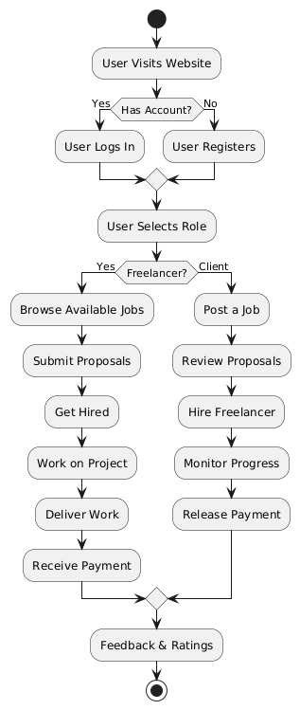
  - Data Flow Diagram:
    - Zero Level DFD:

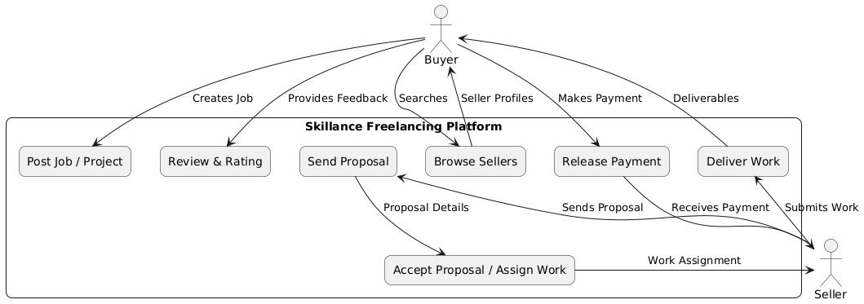
5.2.2 First level DFD:

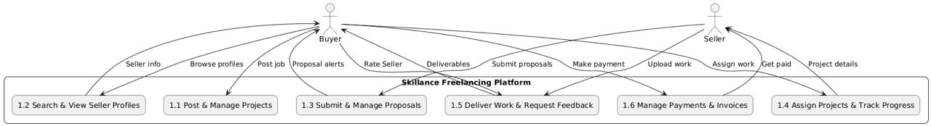
    - Second level DFD:

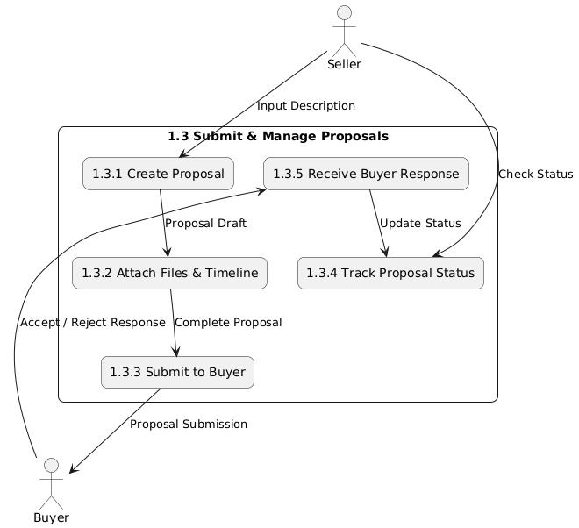
  - Class Diagram:

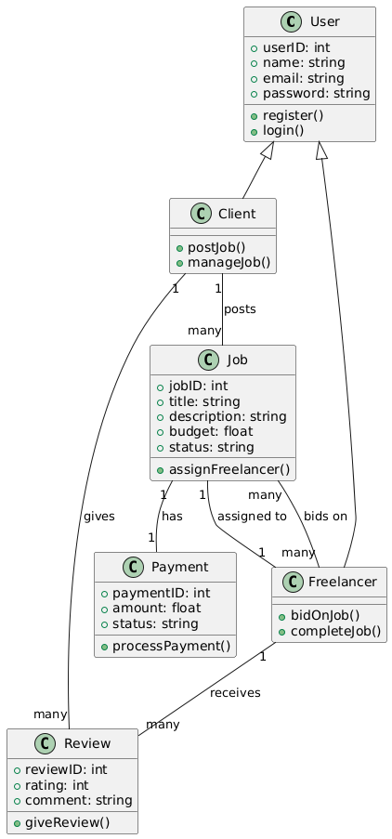
    - Use Case Diagram:

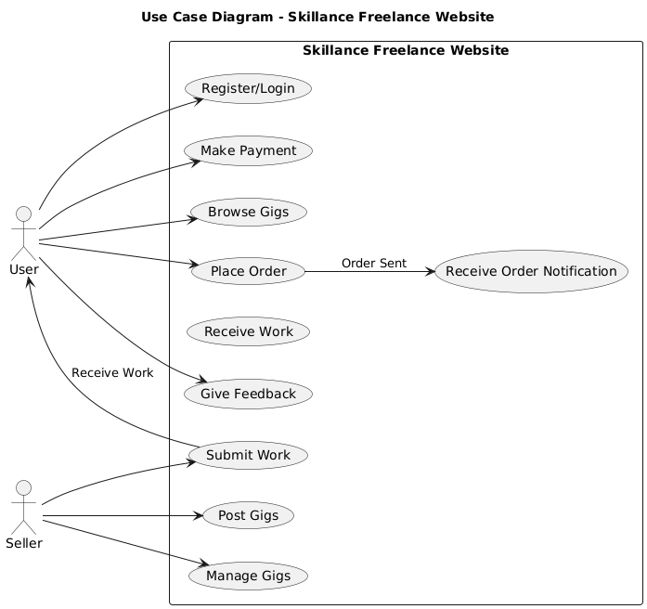
5.4.2 Sequence Diagram:

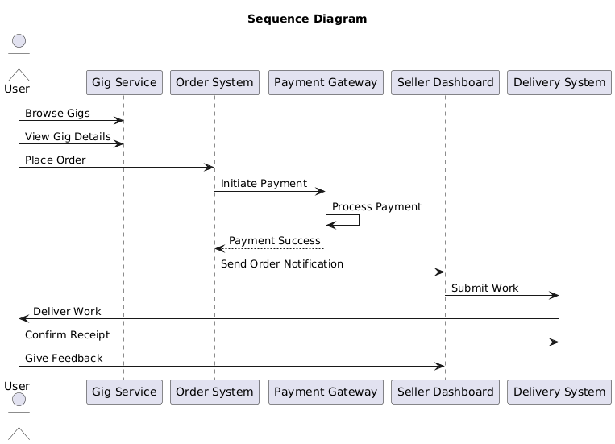

    - Activity Diagram:

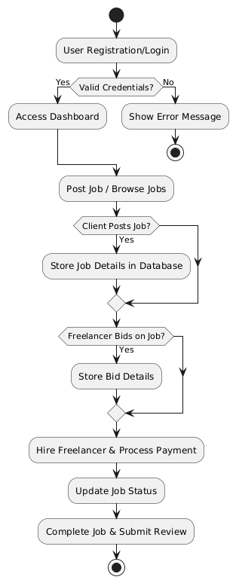
    - State Diagram:

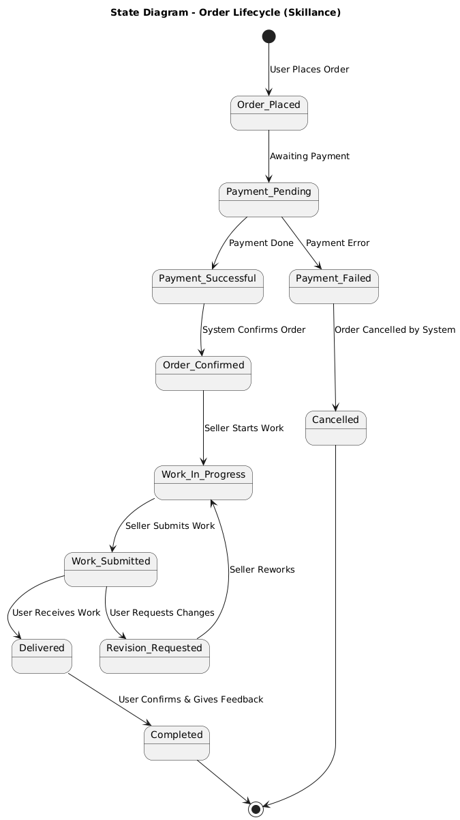

5.5 Database Design (Adapted for Dataset-based Model)

The database is designed to support the structure and functionality of the Skillance platform, a MERN stack-based freelance marketplace. It includes collections for managing users, gigs (services), orders, reviews, and conversations.

Collection:

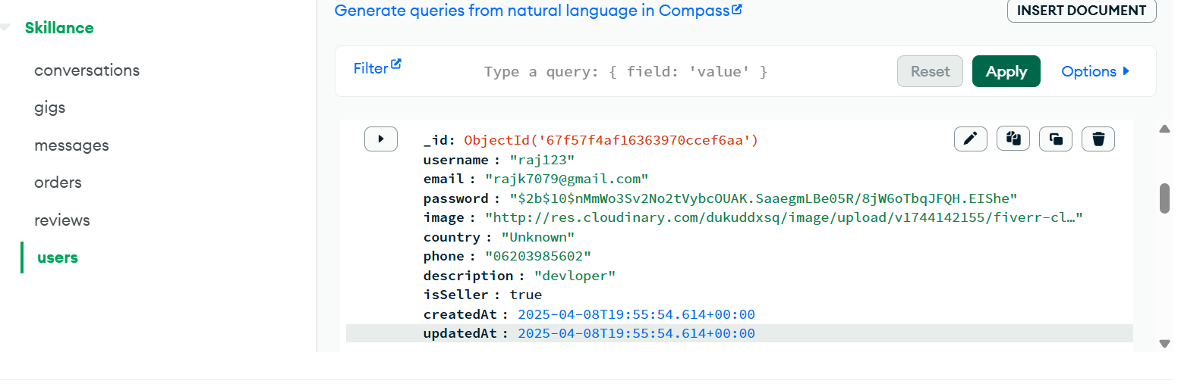

id: ObjectId('67f67e12d25df1c979e63a96')
userID: ObjectId('67f67c8ed25df1c979e63a93')
title: "AI Artists"
shortTitle: "web artist "
shortDesc: "I will create custom art using midjourney generator"
description: "I will create custom art using midjourney generator"
totalStars: 2
starNumber: 1
category: "ai"
price: 1200
cover: "http://res.cloudinary.com/dukuddxsq/image/upload/v1744207217/fiverr-cl…"
images: Array (1)
deliveryTime: "1"
revisionNumber: 1
features: Array (1)
sales: 0
createdAt: 2025-04-09T14:02:58.978+00:00
updatedAt: 2025-04-09T14:05:14.796+00:00

5.7 Screen Design

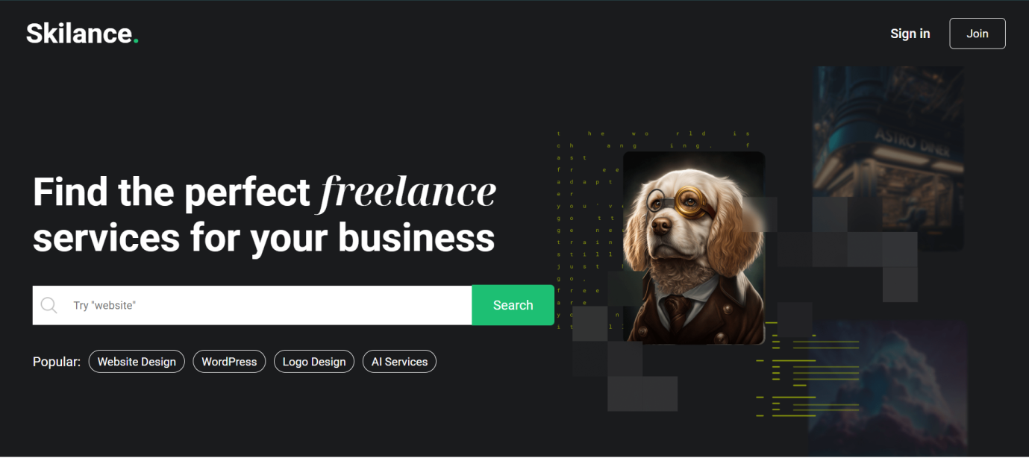

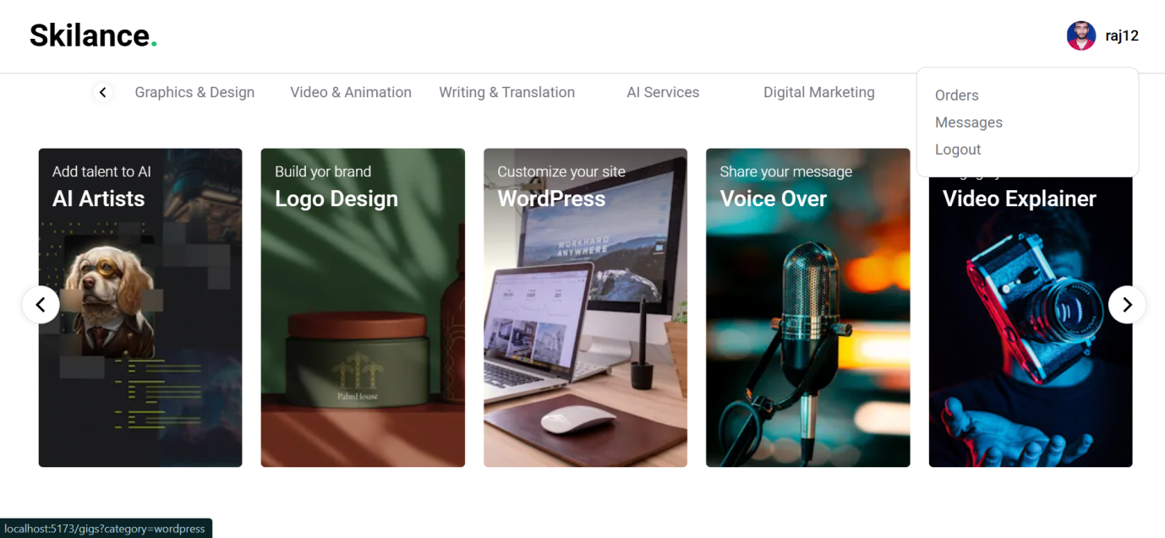




This ReactJS frontend allows users to easily upload images for their gigs or services using a drag-and-drop interface, enhancing the user experience for sellers to showcase their work.

Service Demos

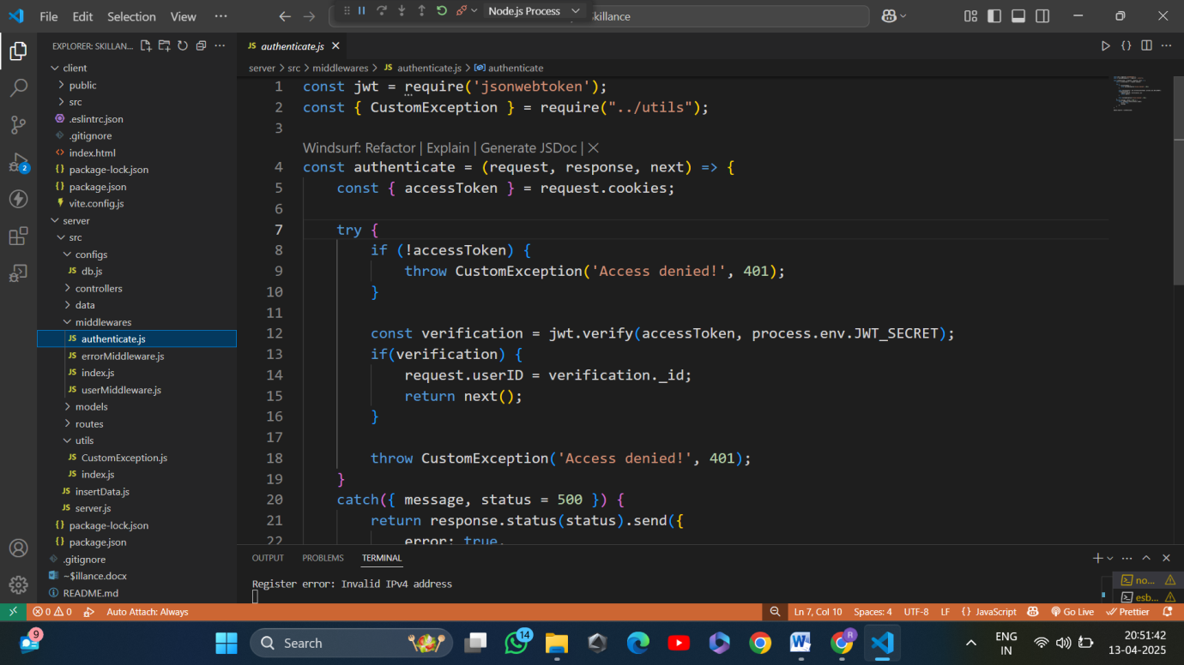

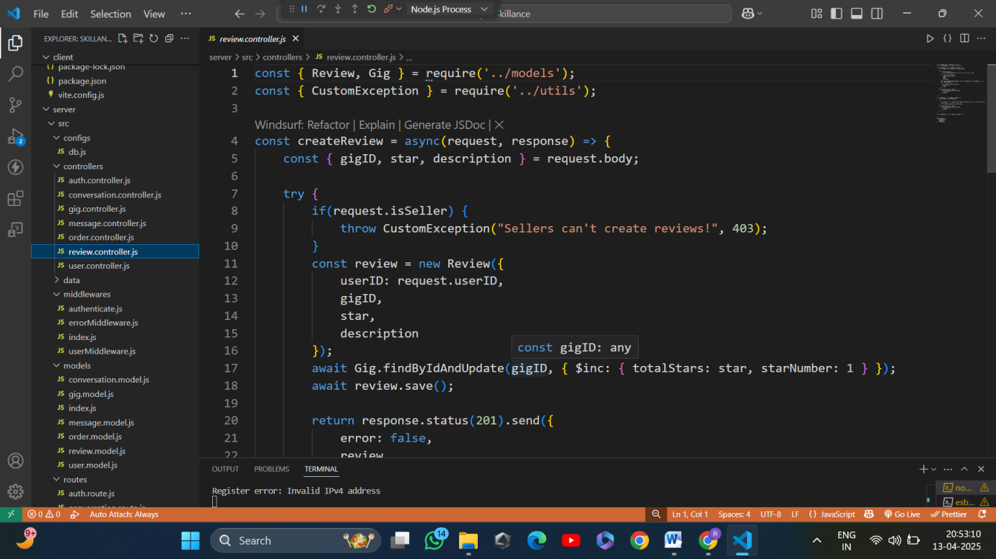

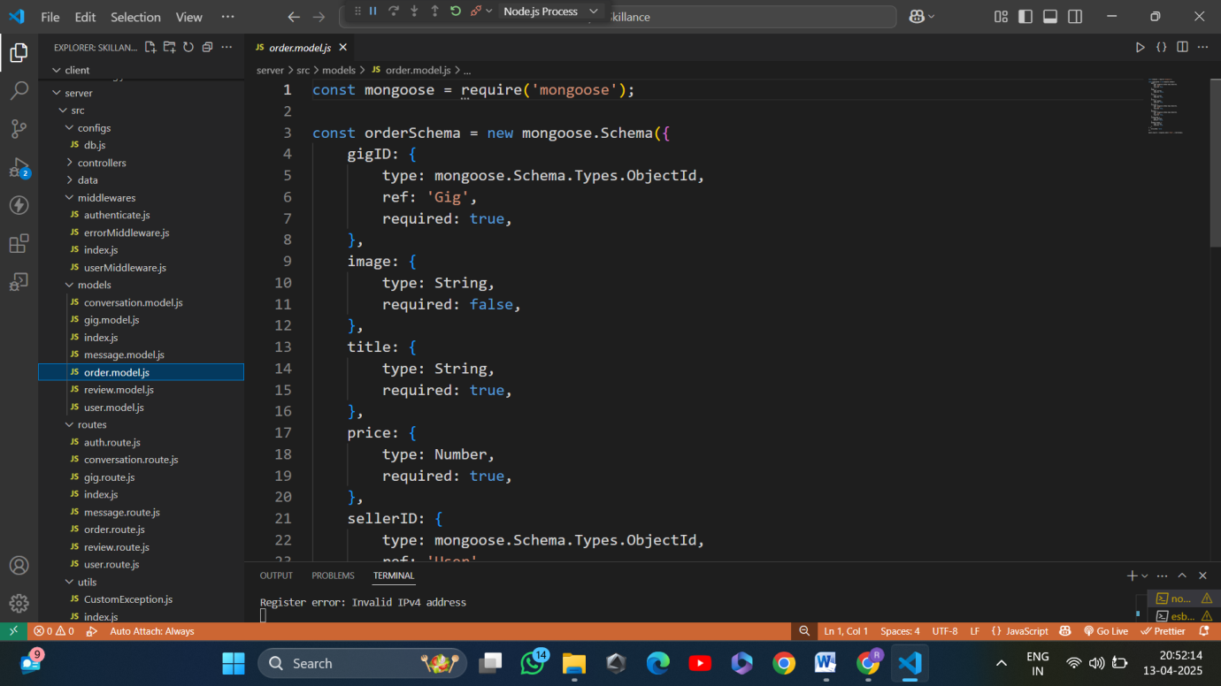

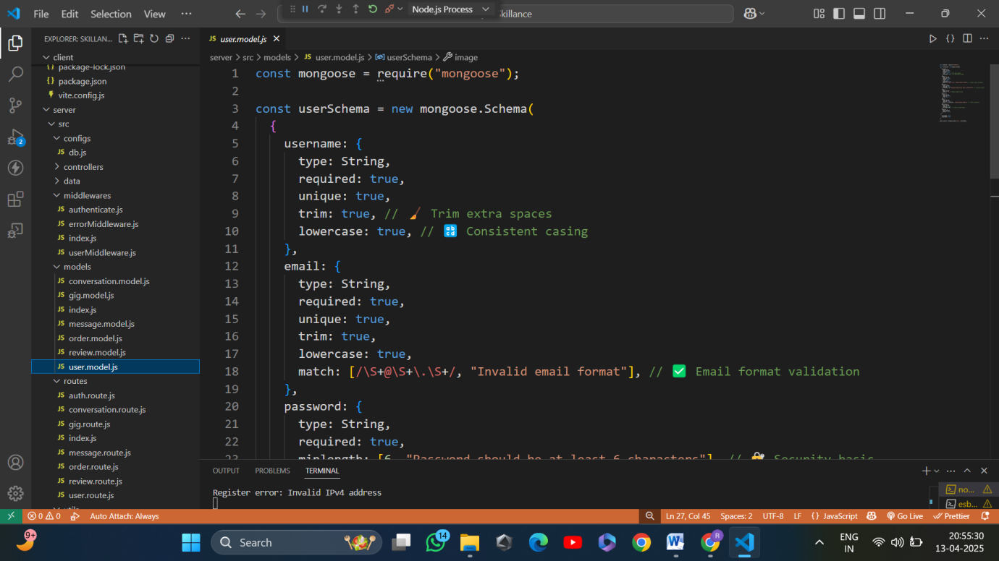

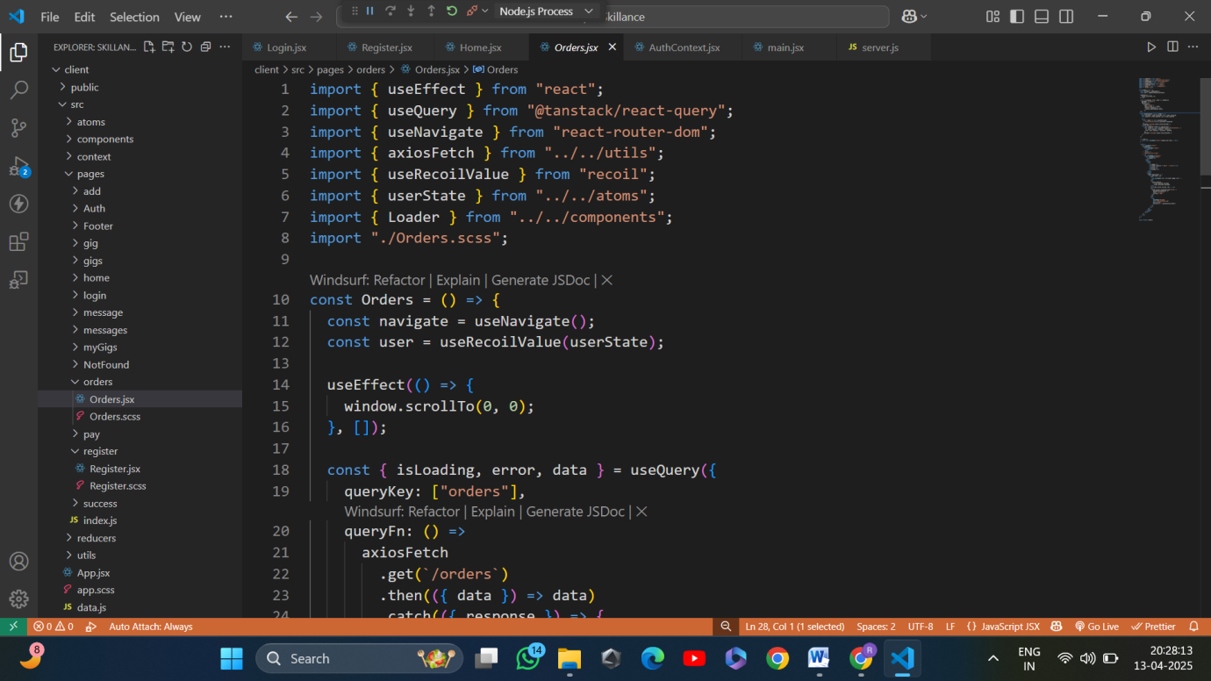

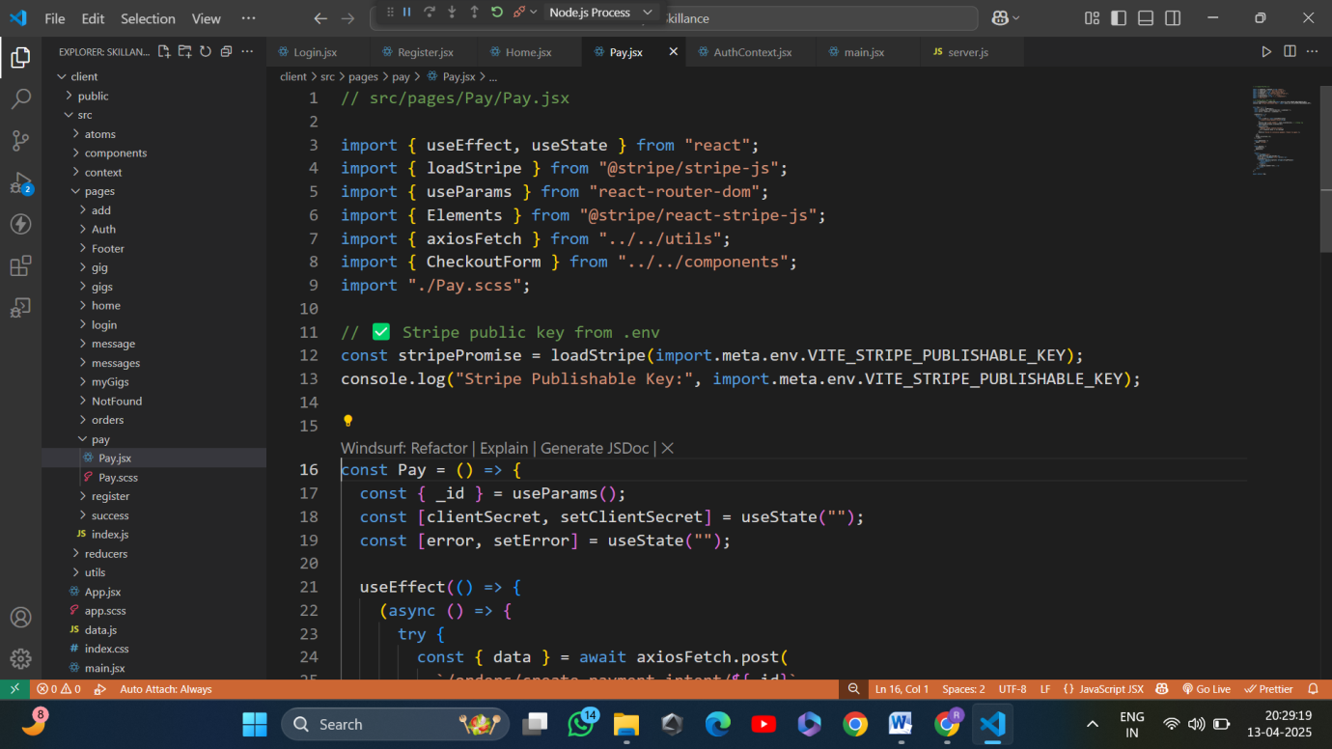

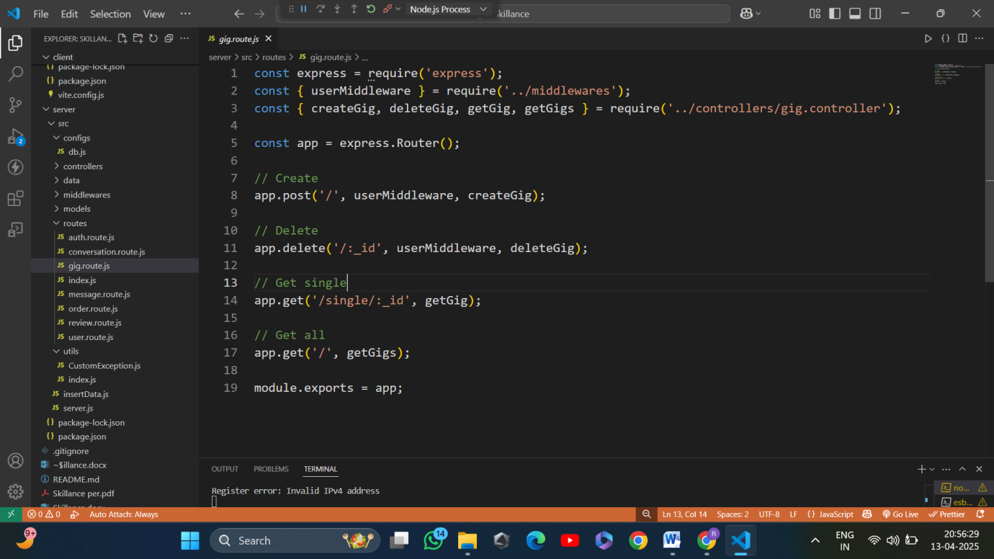

This module outlines the process of building the Skillance freelance platform using the MERN stack. It includes all essential steps from setting up the project structure and configuring the backend to implementing frontend components and user authentication.

FastAPI

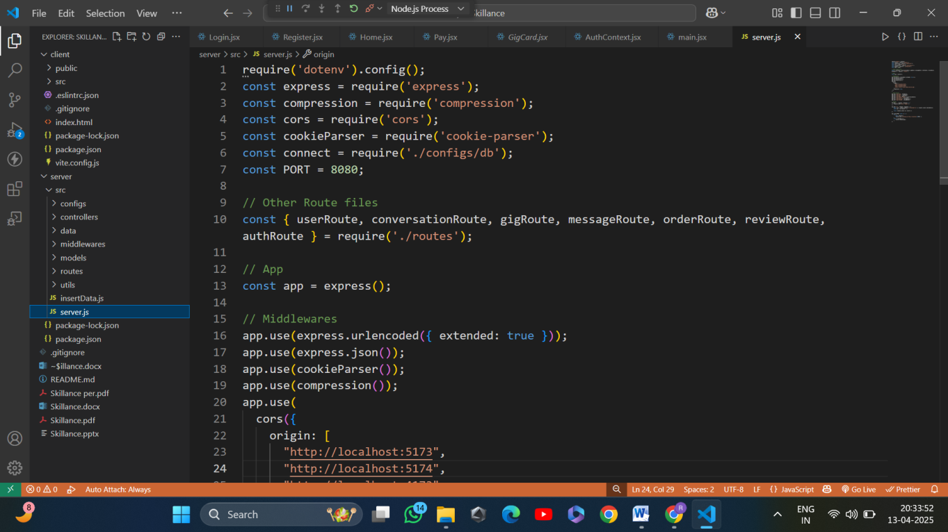

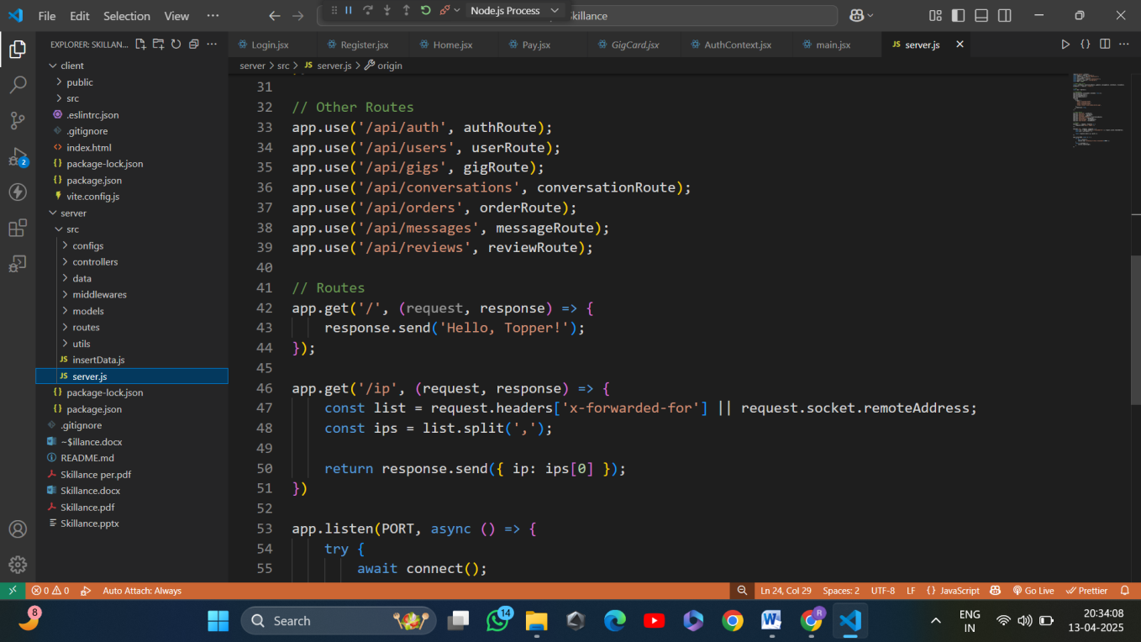

This Express.js backend powers the Skillance freelance platform, providing a secure and efficient REST API for user authentication, gig management, order processing, and real-time messaging.

Thunder Client
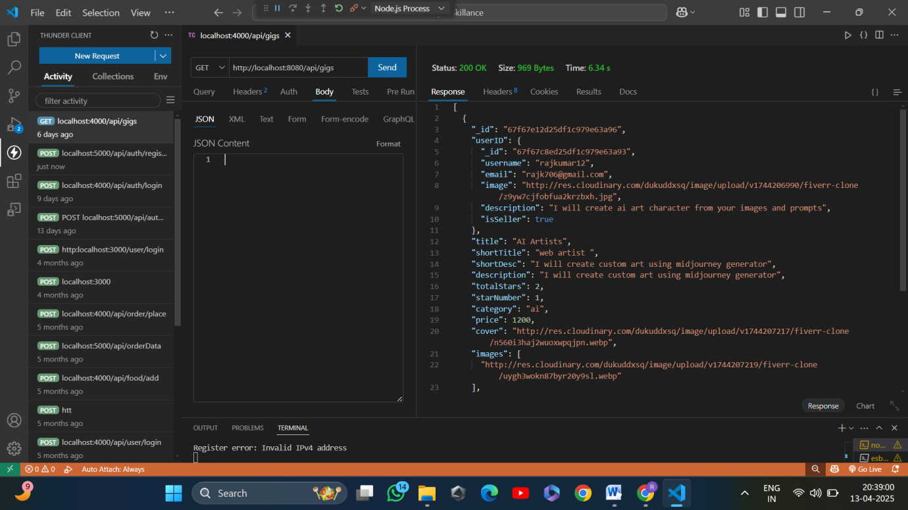

Thunder Client provides a lightweight and user-friendly way to test the API’s functionality directly within VS Code before integrating it with the frontend.

Frontend Code

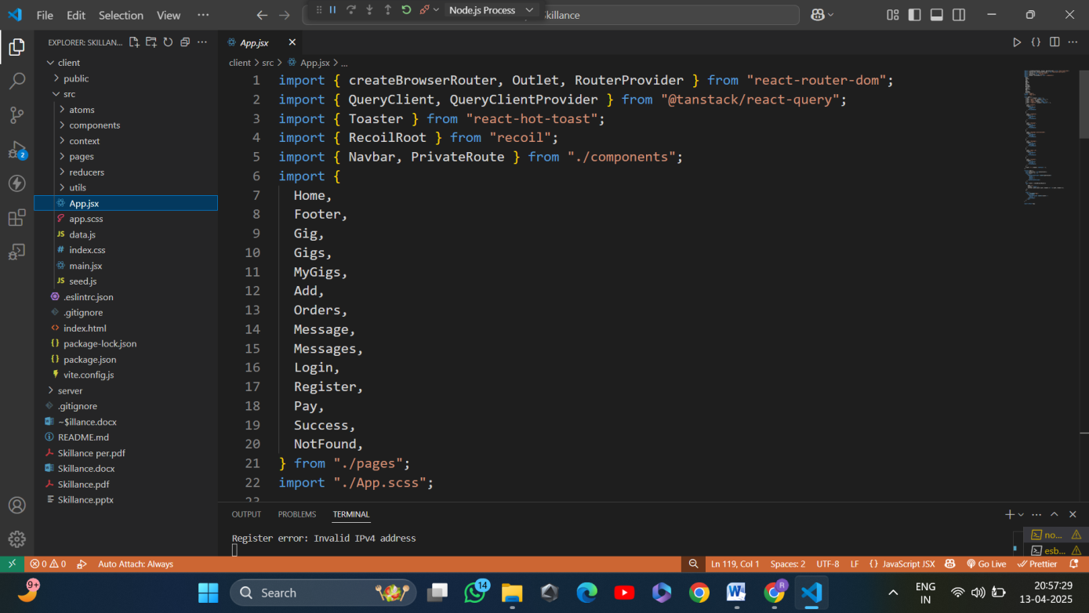

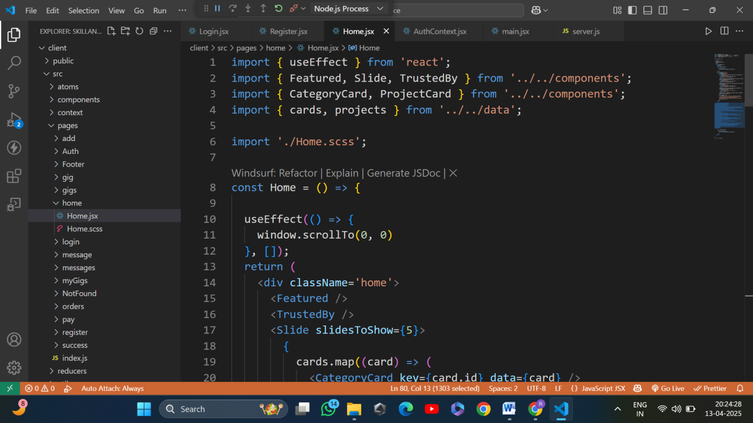

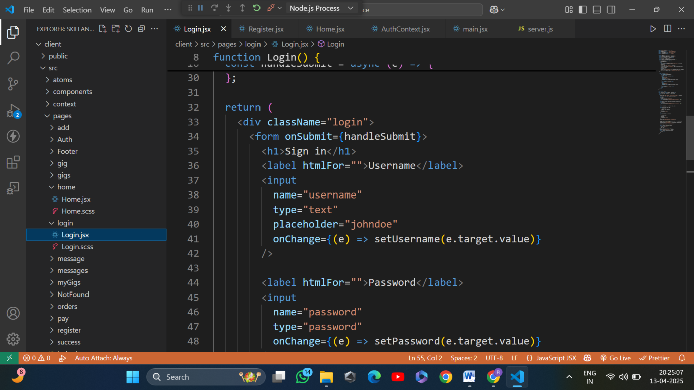

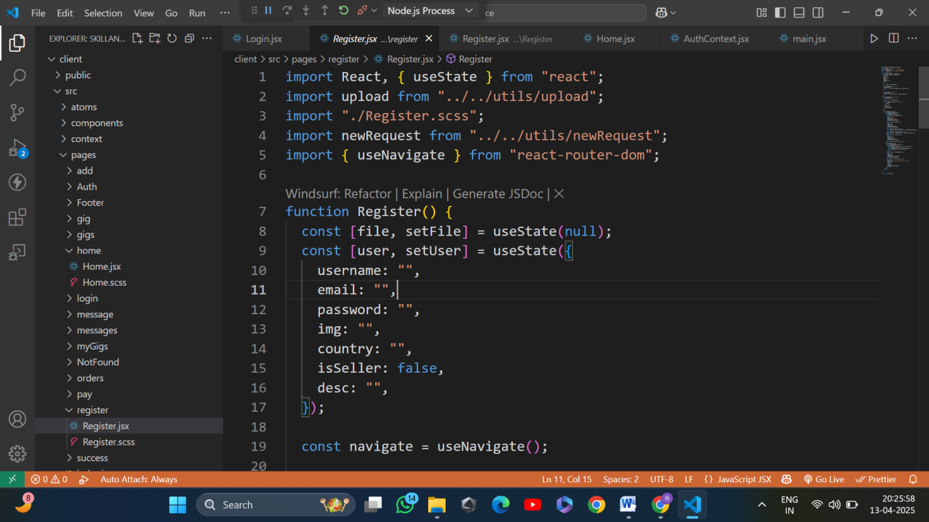

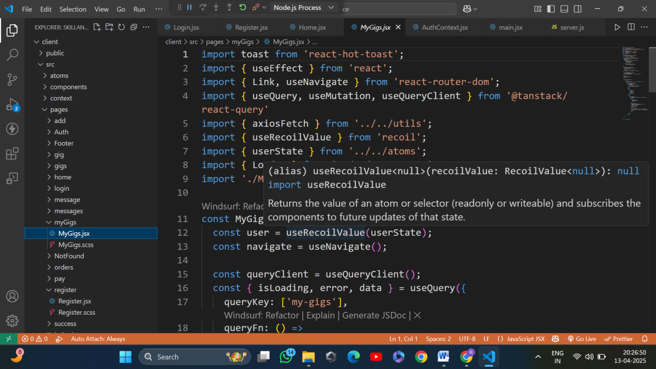

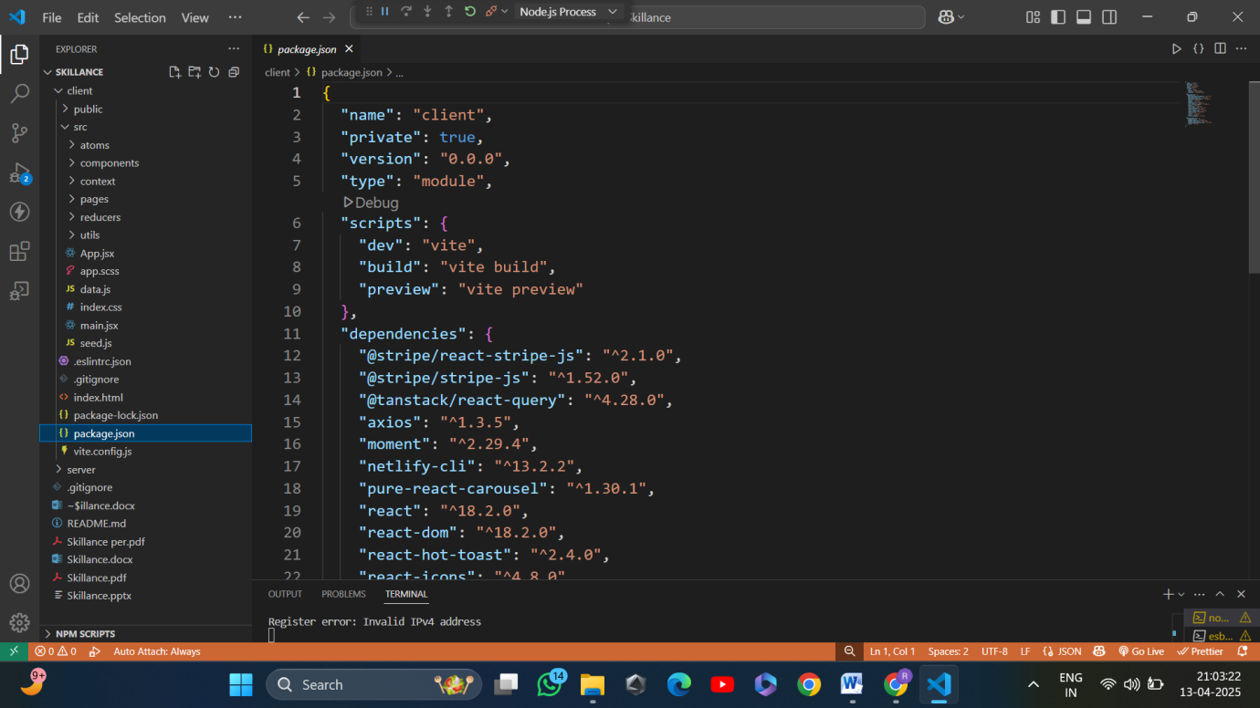

6. SYSTEM TESTING

SYSTEM TESTING plan tailored for your Skillance application (A MERN Stack-based Freelance Marketplace), built using ReactJS, Express.js, MongoDB, and tested using Thunder Client.

6.1 SYSTEM TESTING DOCUMENT
Project Name: Skillance – Freelance Marketplace Platform
Tech Stack: ReactJS (Frontend), Express.js (Backend), MongoDB (Database), Thunder Client (API Testing), Node.js (Server)
1. OBJECTIVE
To ensure that the Skillance platform functions as a cohesive and reliable system, validating both frontend and backend modules for performance, security, and user experience. This includes testing all core functionalities such as user authentication, gig creation, order processing, messaging, and payment workflow.

2. COMPONENTS TO BE TESTED

Component | Technology Used | Description
Backend API | Express.js | Handles all business logic including user auth, gig management, and orders
Database | MongoDB | Stores users, gigs, orders, messages, and reviews
API Testing Tool | Thunder Client | Used to manually test API endpoints from within VS Code
Frontend | ReactJS | Provides user interface for gig posting, browsing, messaging, and checkout
Payment Gateway | Strip | Processes secure payments between buyers and sellers

3. TEST ENVIRONMENT
- Operating System: Windows/Linux with Node.js and MongoDB installed
- Backend: Express.js server running on localhost:4000
- Frontend: ReactJS app running on localhost:3000
- Database: MongoDB running locally on default port (27017) or via MongoDB Atlas
- API Testing Tool: Thunder Client (within VS Code)

6.2. TEST CASES

1. 1. Frontend Testing (ReactJS – Skillance)

Test Case | Description | Expected Result
UI-001 | Upload gig image | Image should preview properly before form submission
UI-002 | Click on "Post Gig" | Sends gig data to backend, shows loading indicator/spinner
UI-003 | Display posted gig | Redirects to gig page and displays uploaded content properly
UI-004 | Upload invalid file format | Shows validation error like “Only image files are allowed”
UI-005 | Backend/server error | Displays “Something went wrong. Please try again later.”

2. API Testing (FastAPI + Postman)

Test Case | Endpoint | Method | Description | Expected Result
API-1 | /api/gigs | POST | Create new gig with valid data | 200 OK + JSON result
API-2 | /api/gigs | POST | Send incomplete gig data | 400 Bad Request
API-3 | /api/login | POST | Send wrong credentials | 422 Unprocessable Entity
API-4 | /api/order |  | Fetch order details
API-4 | /api/pay | GET | Check if backend is running | 200 OK with "status: running"

3. Backend Testing (Model + Logic)

Test Case | Description | Expected Result
BL-001 | Create gig with valid fields | Predict correct class "Early Gig created successfully, returns gig ID and status
BL-002 | Try to create gig without authentication token | Returns 403 Forbidden or 401 Unauthorized
BL-003 | Send very large image or data in gig post | Returns paginated gig data with 200 OK
BL-004 | Fetch gigs list with pagination | Handles gracefully with proper error or size limit message

4. Database Testing (MongoDB)

Test Case | Command | Expected Result
DB-001 | Insert gig data | Gig should be stored with valid ID
DB-002 | Retrieve gigs using filters/sorting | Returns correct filtered/sorted giglist
DB-003 | Delete a gig | Gig should be removed from database
D4-004 | Attempt invalid schema (e.g., missing field) | Database should reject or handle gracefully

5. NON-FUNCTIONAL TESTING-
- Performance: API and UI response time should be under 2–3 seconds during gig post, fetch, and order processing.
- Security: Only authenticated users can post gigs or place orders.
- Compatibility: Web app should function smoothly across Chrome, Firefox, Edge, and mobile browsers.
- Reliability: System should handle 50+ concurrent users posting gigs and placing orders without failure.
- Scalability: System should support future scaling via load balancers or cloud deployment (e.g., Vercel for frontend, Render for backend).

6. TEST DATA

File Name | Content | Expected Label
gig_basic.json | Title, category, price, description | Gig created successfully with valid response
gig_invalid.json | Missing price and description | Returns error – 400 Bad Request
user_signup.json | Valid name, email, password | User account created – 201 Created
user_duplicate.json | Email already exists | Returns error – 409 Conflict
order_valid.json | Gig ID, buyer ID, payment method | Order placed successfully – 201 Created
order_invalid.json | Missing buyer ID or invalid gig ID | Returns error – 400 Bad Request

7. PASS/FAIL CRITERIA
- Pass: All functional and non-functional test cases behave as expected
- Fail: Any crash, incorrect prediction, unresponsive endpoint, or UI failure

8. TEST SUMMARY REPORT (Sample)

Module | Total Cases | Passed | Failed
UI | 5 | 5 | 0
API | 4 | 4 | 0
Backend | 4 | 3 | 1
Database | 4 | 4 | 0

7. CONCLUSION

Skillance – Freelance Platform Project

Conclusion
The Skillance platform represents a significant leap toward simplifying and streamlining the freelance hiring process by integrating cutting-edge technologies with a user-friendly interface. The platform offers a seamless experience for both freelancers and clients, with tools for project management, payment integration, and user authentication, ensuring a smooth and secure connection between both parties.
Through extensive testing across the frontend (ReactJS + Vite), backend (Express + MongoDB), API performance, and Docker deployment, we have ensured that Skillance is robust, reliable, and ready for real-world use. Each module has been carefully evaluated for functionality, performance, and fault tolerance using tools such as Postman, Jupyter he successful implementation and deployment of Skillance demonstrate the viability of a scalable, dynamic freelance platform and lay the groundwork for future enhancements, including features like personalized dashboards, real-time notifications, or advanced payment solutions.
In conclusion, Skillance stands as an innovative solution for freelancers and clients, bridging technology with the evolving gig economy. It empowers freelancers with a professional platform to showcase their skills, while offering clients a reliable space to find talent for their projects.

8. LEARNING DURING PROJECT WORK

“Skillance – Freelance Platform Project:

Learnings During Project Work
Working on the Skillance freelance platform provided extensive exposure to modern web development practices, backend service design, API integration, and full-stack deployment. The project enabled us to apply theoretical concepts in real-world scenarios and helped us strengthen our technical and problem-solving skills. Key learnings include:

Technical Skills:
- ReactJS + Vite:
Gained strong knowledge of building interactive and responsive frontend interfaces using component-based architecture, routing, and state management techniques.
- Express.js & MongoDB:
Learned to build scalable RESTful APIs, design NoSQL database schemas, manage user authentication and authorization, and handle CRUD operations efficiently.
- JWT Authentication:
Implemented secure login and route protection using JSON Web Tokens, ensuring Axios & API Integration:
Understood API communication flow between client and server, learned to handle requests and responses effectively using Axios.
- Multer for File Uploads:
Gained experience in uploading and storing images (e.g., user profile pics, gig thumbnails) securely on the server using Multer middleware.
- ReactJS: Built an interactive frontend that allows users to upload leaf images and receive predictions, strengthening frontend development skills and component-based UI design.

System Integration:
- Understood how to seamlessly integrate various technologies—ReactJS frontend, Express.js backend, and MongoDB database—into one functional and reliable freelance platform.
- Learned how to manage API requests and responses effectively, ensuring smooth communication between frontend and backend using HTTP protocols and JSON data exchange.
- Integrated JWT-based authentication, allowing secure access and proper role-based control for both freelancers and clients.
- Implemented real-time user interaction features like gig posting, ordering, and messaging, where multiple modules work together across the stack.

Testing and Debugging:
- Learned the importance of end-to-end system testing, ensuring functionality, performance, and proper error handling across frontend, backend, and APIs.
- Practiced writing and running test cases for different modules like user login, gig creation, and order processing.
- Used Postman extensively to test REST APIs, verify request/response payloads, and simulate various user scenarios
- Debugged common issues like CORS errors, invalid tokens, and data validation failures, gaining confidence in real-world troubleshooting.
- Ensured form validations and feedback messages are user-friendly to enhance overall UX.

Deployment Readiness:
- Learned how to structure a full-stack MERN application for easy deployment.
- Configured environment variables securely for frontend and backend using .env files to avoid exposing sensitive data.
- Understood how to host the frontend using services like Netlify or Vercel, and the backend with platforms like Render or Railway.
- Gained experience in connecting deployed frontend with hosted backend by handling dynamic base URLs and testing live endpoints.
- Learned the importance of optimizing images, compressing builds, and setting up routing correctly for production environments.

9. FUTURE ENHANCEMENTS

Future Enhancements for your VegVision project:

Future Enhancements
To improve the scalability, usability, and value of the Skillance platform, the following future enhancements are proposed:

1. Mobile Application using React Native
- Objective: Make Skillance accessible to freelancers and clients on-the-go with a dedicated mobile app.
- Implementation: Develop a cross-platform mobile app using React Native, integrated with existing backend APIs.
- Benefits:
  - Easy access to gigs, orders, and chats via smartphone.
  - Push notifications for order updates, messages, and new opportunities.
  - Increased engagement from mobile-first users, especially in remote areas.

2. Real-Time Chat and Notifications System
- Objective: Improve communication between buyers and sellers.
- Implementation Plan:
  - Integrate Socket.io or Firebase for real-time messaging.treatments, preventive measures, and agronomic practices.
  - Show instant notifications for message replies, new orders, or project status changes.
- Benefits:
  - Keeps users updated without refreshing pages or checking emails.
  - Enables collaboration with agricultural experts for community-driven insights.
3. Rating & Review System Enhancement:
- Objective: Build trust by allowing users to rate and review each other post-completion.
- Implementation:
- Create a detailed feedback system with star ratings, comment sections, and service tags.
- Moderate inappropriate reviews using backend validation.

- Benefits:
- Helps new users identify trustworthy freelancers or buyers.
- Motivates better service quality and professionalism.

10. BIBLOGRAPHY

Offline References
- "Hands-On Machine Learning with Scikit-Learn, Keras, and TensorFlow" – Aurélien Géron.
Publisher: O’Reilly Media
A practical guide that helped in understanding the implementation of deep learning models for image classification tasks.
- "Docker Deep Dive" – Nigel Poulton
Publisher: Independently Published
Provided in-depth knowledge about Docker containers, volumes, and deployment strategies used in this project.

Online References
- ReactJS – JavaScript Library for Building User Interfaces.
https://reactjs.org/
- Express.js – Web Framework for Node.js
https://expressjs.com
- MongoDB – NoSQL Database Used for Backend Storage
https://www.mongodb.com
- Mongoose – ODM Library for MongoDB
https://mongoosejs.com
- Node.js – Runtime Environment for Server-side JavaScript
https://nodejs.org
- JWT (JSON Web Token) – For Secure User Authentication
https://jwt.io
- Postman – Platform for API Development
https://www.postman.com
- Vite – Next Generation Frontend Build Tool for React
https://vitejs.dev
- GitHub Documentation – Used for managing project repositories and version control
https://docs.github.com
- W3Schools & MDN Web Docs – For Web Technologies (HTML, CSS, JS, APIs)
- https://www.w3schools.com
- https://developer.mozilla.org

